Part 1:

Class is describing the objects and what the objects do.

Object is part of class, which to create the class

The difference between class and object: **class** have a lot of objects to make the class work and the class wouldn’t work without object.

Class made up of attributes section and behavior section

The difference between private and public: **private** The variable can only be used in the code file which it is declared in. **public** The variable can be used by any code file in the project.

The class used in Visual basic application as function.

Part 2:

Time class

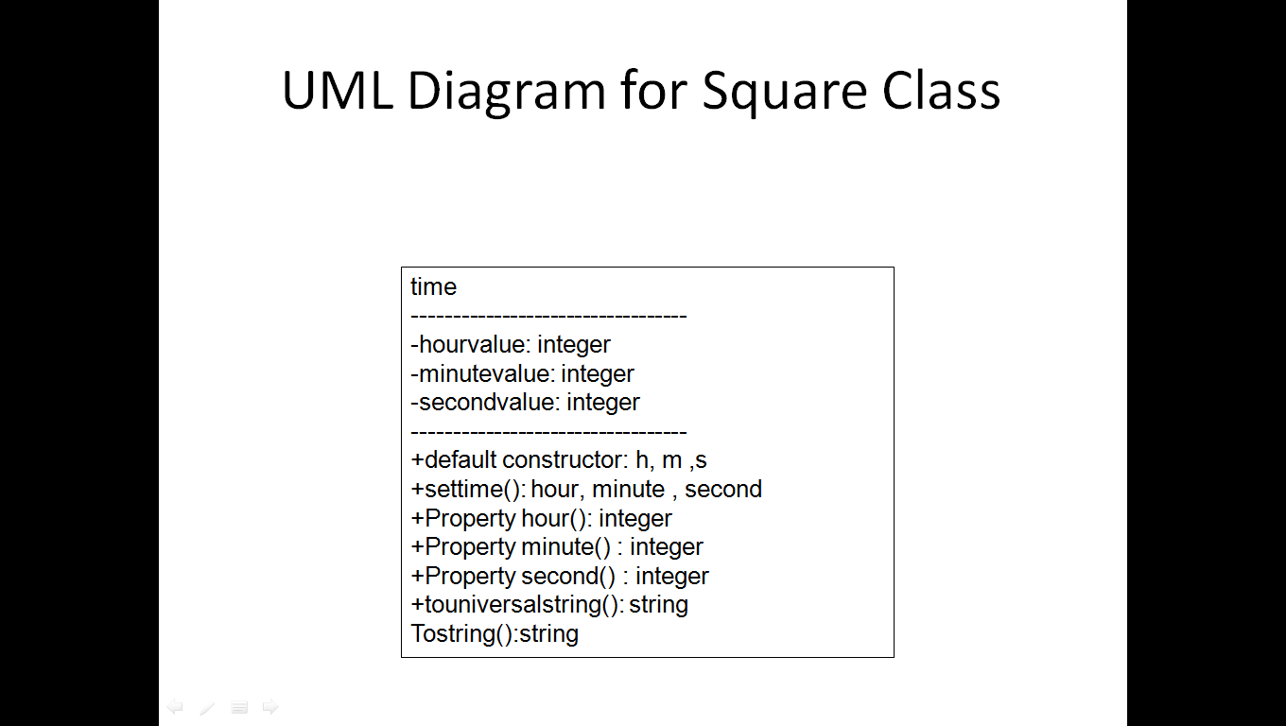

Emplyee class

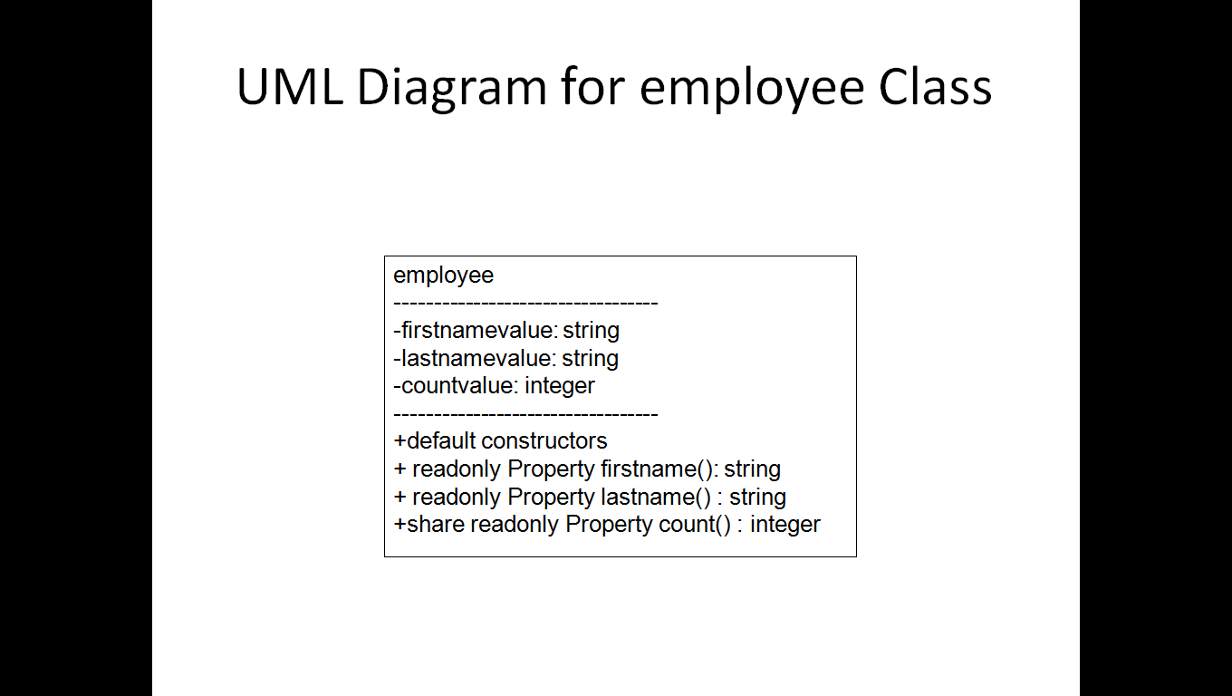

Part3:

Account

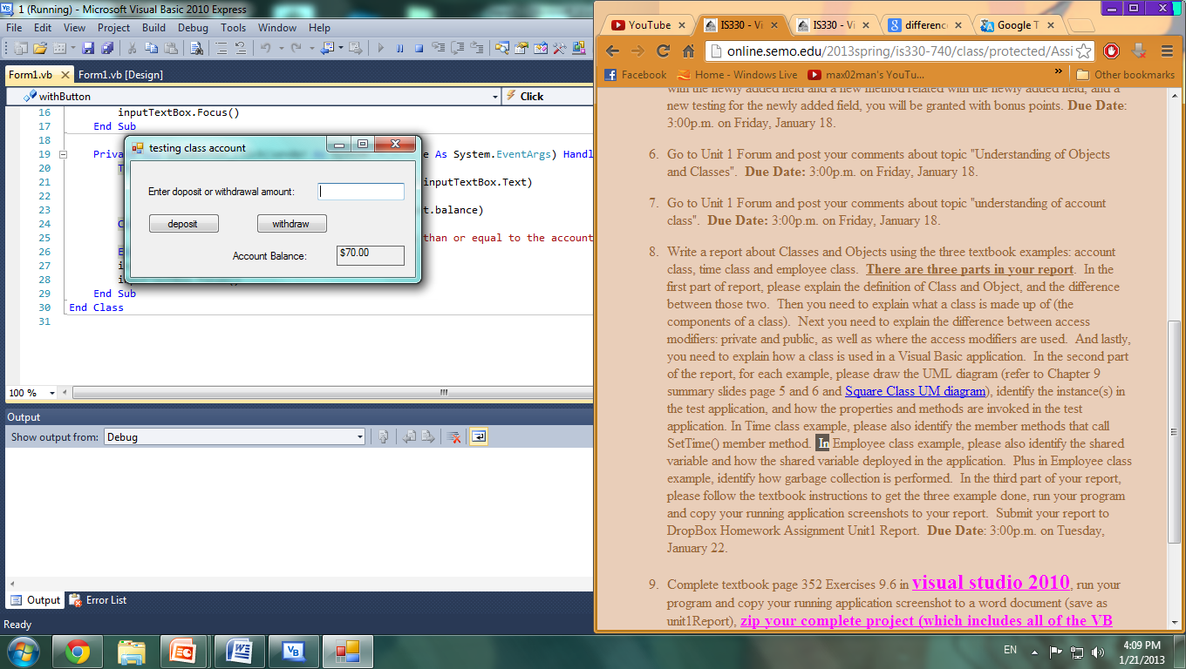

Time

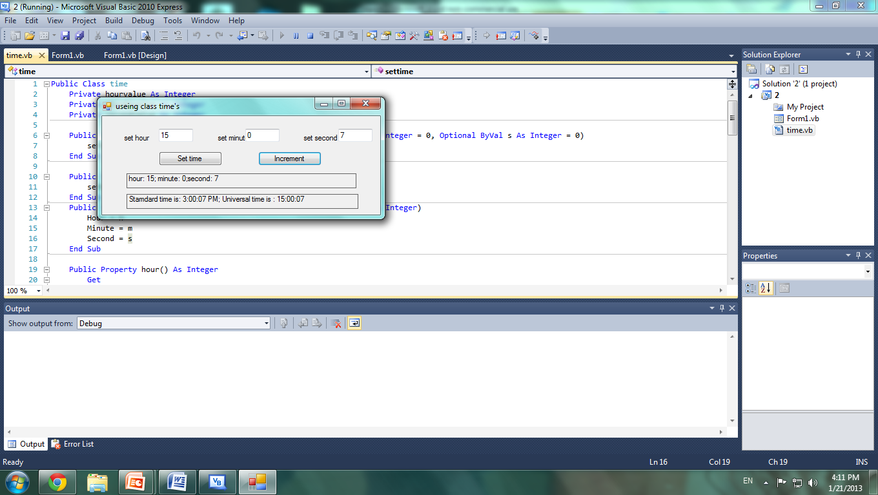

Employee

